­

**PRACTICAL – 2**

1. **Basics of CSS and Types of CSS**

CSS is a style language that defines layout of HTML documents. For example, CSS covers fonts, colors, margins, lines, height, width, background images, advanced positions and many other things.

The separation of HTML from CSS makes it easier to maintain sites, share style sheets across pages, and tailor pages to different environments. This is referred to as the separation of structure (or: content) from presentation.

The concrete benefits of CSS include:

* control layout of many documents from one single style sheet;
* more precise control of layout;
* apply different layout to different media-types (screen, print, etc.);
* numerous advanced and sophisticated techniques.

**CSS Syntax**

A CSS rule set consists of a selector and a declaration block:

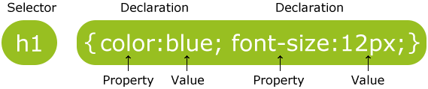

The selector points to the HTML element you want to style.

The declaration block contains one or more declarations separated by semicolons.

Each declaration includes a property name and a value, separated by a colon.

**Types of CSS**

1. Inline Style (inside (X)HTML element)

2. Internal Style Sheet (inside the <head> tag)

3. External Style Sheet

**Inline Styles**

Inline styles are defined right in the (X)HTML file alongside the element you want to style. See example below.

<p style="color: #ff0000;">Some red text</p>

Some red text

Inline styles will NOT allow the user to change styles of elements or text formatted this way.

**Internal Stylesheet**

In this way CSS code is placed within the <head></head> tags of each (X)HTML file you want to style with the CSS. The format for this is shown in the example below.

<head>

<title><title>

<style type="text/css">

CSS Content Goes Here

</style>

</head>

<body>

With this method each (X)HTML file contains the CSS code needed to style the page. Meaning that any changes you want to make to one page, will have to be made to all. This method can be good if you need to style only one page, or if you want different pages to have varying styles.

**External Stylesheet**

An external CSS file can be created with any text or HTML editor such as "Notepad" or "Dreamweaver". A CSS file contains no (X)HTML, only CSS. You simply save it with the .css file extension. You can link to the file externally by placing one of the following links in the head section of every (X)HTML file you want to style with the CSS file.

<head>

<title><title>

<link rel="stylesheet" type="text/css"href="style.css" />

</head>

<body>

or

<head>

<title><title>

<style type="text/css"> @import url(Path To stylesheet.css)

</style>

</head>

<body>

By using an external style sheet, all of your (X)HTML files link to one CSS file in order to style the pages. This means, that if you need to alter the design of all your pages, you only need to edit one .css file to make global changes to your entire website.

Here are a few reasons this is better.

* Easier Maintenance
* Reduced File Size
* Reduced Bandwidth
* Improved Flexibility

**B:-Create structure of website using div tag and CSS.**

**Html:-**

<!DOCTYPE html PUBLIC "-//W3C//DTD XHTML 1.0 Transitional//EN" "http://www.w3.org/TR/xhtml1/DTD/xhtml1-transitional.dtd">

<html xmlns="http://www.w3.org/1999/xhtml">

<head>

<meta http-equiv="Content-Type" content="text/html; charset=utf-8" />

<title>jewellery_shop</title>

<link type="text/css" href="prtc2_2.css" rel="stylesheet" >

</head>

<body>

<div class="outer">

<div class="upclass">

<div class="logo"></div>

<div class="slider">

<div class="menu">

<ul>

<a href="html1.html"><li>home</li></a>

<a href="html2.html"><li>woman</li></a>

<a href="html3.html"><li>man</li></a>

<a href="html4.html"><li>diamond</li></a>

<a href="html5.html"><li>about us</li></a>

</ul>

</div>

</div>

<div class="welcome"><h3>WELCOME TO OUR WEBSITE...</h3></div>

</div>

<div class="downclass"><H1>

<div class="down_left"></div>

<div class="down_right"></div>

<div class="footer"></div>

</div>

</div>

</body>

</html>

**CSS:-**

{

body

margin:opx;

}

.outer{

height:800px;

width:1000px;

margin:0px auto;

background:#CF6

}

.upclass{

float:left;

height:350px;

width:1000px;

background:#306

}

.logo{

height:250px;

width:1000px;

float:left;

background:#6C6

}

.slider{

height:60px;

clear:left;

width:1000px;

float:left;

background:#CC3

}

.menu{

float:left;

height:50px;

width:1000px;

font-size:20px;

color:#666;

}

.menu ul{

margin-left:-40px

}

.menu li{

display:inline;

background:#000;

color:#CCC;

padding:18px 68px

}

.menu li:hover{

background:#03C;

color:#fff;

}

.menu a{

text-decoration:none

}

.welcome{

float:left;

clear:left;

height:40px;

width:1000px;

background:#F36;

}

.downclass{

float:left;

clear:left;

height:450px;

width:1000px;

background:#930

}

.down_left{

float:left;

clear:left;

height:400px;

width:700px;

background:#F39

}

.down_right{

float:left;

clear:right;

height:400px;

width:300px;

background:#6C9

}

.footer{

float:left;

height:50px;

width:1000px;

background:#C9F

}

**OUTPUT:-**

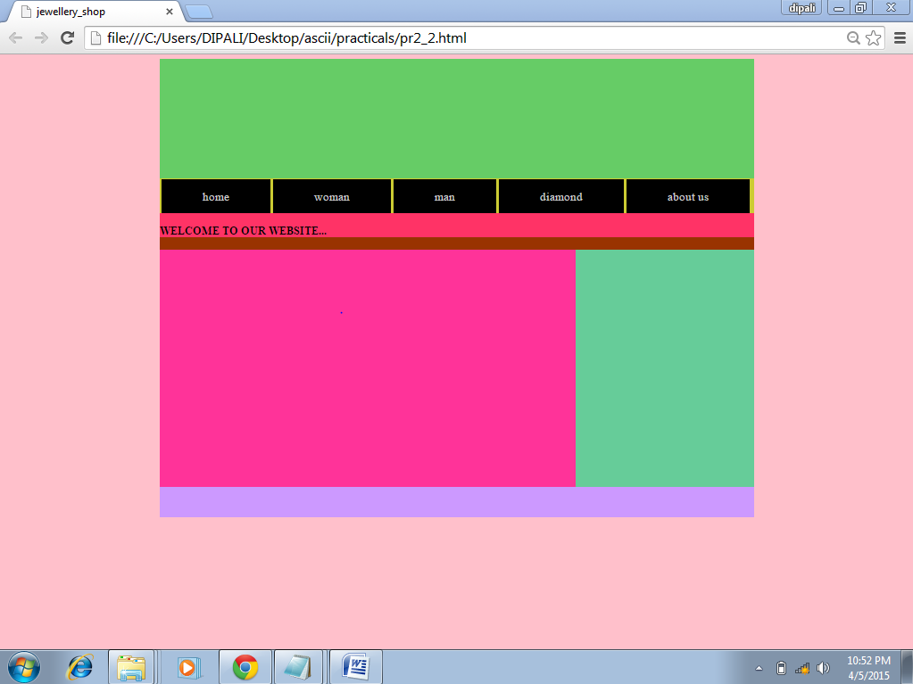

**C:-** **Create 5 pages website with content using div tag CSS.**

**Page:-1(home page)**

**Html:-**

<!DOCTYPE html PUBLIC "-//W3C//DTD XHTML 1.0 Transitional//EN" "http://www.w3.org/TR/xhtml1/DTD/xhtml1-transitional.dtd">

<html xmlns="http://www.w3.org/1999/xhtml">

<head>

<meta http-equiv="Content-Type" content="text/html; charset=utf-8" />

<title>Home</title>

<link type="text/css" href="css1.css" rel="stylesheet" >

</head>

<body>

<div class="outer">

<div class="upclass">

<div class="logo"><img src="../images/banner1-960x300.jpg" height="250px" width="1000px"/></div>

<div class="slider">

<div class="menu">

<ul>

<a href="html1.html"><li>home</li></a>

<a href="html2.html"><li>men</li></a>

<a href="html3.html"><li>women</li></a>

<a href="html4.html"><li>diamond</li></a>

<a href="html5.html"><li>About Us</li></a>

</ul>

</div>

</div>

<div class="welcome"><h3></h3></div>

</div>

<div class="downclass"><H1>

<div class="down_left"><img src="../img/17-4273.jpg" height="400px" width="700px" /></div>

<div class="down_right"><img src="../images/DBrooch (1).jpeg" height="400px" width="300px"/>

</div>

<div class="footer">

</div>

</div>

</div>

</body>

</html>

**CSS:-**

{

body

margin:opx;

}

.outer{

height:800px;

width:1000px;

margin:0px auto;

background:#CF6

}

.upclass{

float:left;

height:350px;

width:1000px;

background:#306

}

.logo{

height:250px;

width:1000px;

float:left;

background:#6C6

}

.slider{

height:60px;

clear:left;

width:1000px;

float:left;

background:#CC3

}

.menu{

float:left;

height:50px;

width:1000px;

font-size:20px;

color:#666;

}

.menu ul{

margin-left:-40px

}

.menu li{

display:inline;

background:#000;

color:#CCC;

padding:18px 68px

}

.menu li:hover{

background:#03C;

color:#fff;

}

.menu a{

text-decoration:none

}

.welcome{

float:left;

clear:left;

height:40px;

width:1000px;

background:#F36;

}

.downclass{

float:left;

clear:left;

height:450px;

width:1000px;

background:#930

}

.down_left{

float:left;

clear:left;

height:400px;

width:700px;

background:#F39

}

.down_right{

float:left;

clear:right;

height:400px;

width:300px;

background:#6C9

}

.footer{

float:left;

height:50px;

width:1000px;

background:#C9F}

**Page:-2(man page)**

**HTML:-**

<!DOCTYPE html PUBLIC "-//W3C//DTD XHTML1.0 Transitional//EN"

"http://www.w3.org/TR/xhtml1/DTD/xhtml1-transitional.dtd">

<htmlxmlns="http://www.w3.org/1999/xhtml">

<head>

<meta http-equiv="Content-Type" content="text/html; charset=utf-8" />

<title>Untitled Document</title>

<link type="text/css" href="css2.css"rel="stylesheet" >

</head>

<body bgcolor="pink">

<div class="outer">

<div class="upclass">

<div class="logo">

<img src="../images/banner1-960x300.jpg"height="300px" width="1000px"/></div>

<div class="slider">

<div class="menu">

<ul>

<a href="html1.html"><li>home</li></a>

<a href="html2.html"><li>men</li></a>

<a href="html3.html"><li>women</li></a>

<a href="html4.html"><li>diamond</li></a>

<a href="html5.html"><li>About Us</li></a>

</ul>

</div>

</div>

</div>

<div class="downclass">

<div class="down_left">

<div class="space1"></div>

<div class="manimg1"><img src="../images/CGRing.(1).jpg" height="200px" width="195px"/></div>

<div class="manimg2"><img src="../images/GWatch.(3).jpg" height="200px" width="195px"/></div>

<div class="manimg3"><img src="../img/IMG-20150201-WA0025.jpg" height="200px" width="195px"/></div>

<div class="manimg4"><img src="../images/DRing.(6).jpg" height="200px" width="200px"/></div>

<div class="p1" align="center"><h2>20000rp</h2></div>

<div class="p2 "align="center"><h2>40000rp</h2></div>

<div class="p3" align="center"><h2>27000rp</h2></div>

<div class="p4" align="center"><h2>30000rp</h2></div>

<div class="space2"></div>

</div>

<div class="down_right"><img src="../images/ab2.jpeg" height="400px" width="200px" />

</div>

<div class="footer">

</div>

</div>

</div>

</body>

</html>

**CSS:-**

@charset "utf-8";

/* CSS Document */

{

body

margin:opx;

}

.outer{

height:800px;

width:1000px;

margin:0px auto;

background:#CF6

}

.upclass{

float:left;

height:350px;

width:1000px;

background:#306

}

.logo{

height:250px;

width:1000px;

float:left;

background:#363

}

.slider{

height:50px;

clear:left;

width:1000px;

float:left;

background:#3F6

}

.menu{

float:left;

height:100px;

width:1000px;

}

.menu ul{

margin-left:-37px

}

.menu li{

display:inline;

background:#000;

color:#CCC;

padding:17px 75px

}

.menu li:hover{

background:#03C;

color:#fff;

}

.menu a{

text-decoration:none

}

.downclass{

float:left;

clear:left;

height:450px;

width:1000px;

background:#930

}

.down_left{

float:left;

clear:left;

height:400px;

width:800px;

background:#F39

}

.space1{

float:left;

height:75px;

width:800px;

background:#CCF

}

.manimg1{

float:left;

clear:left;

height:200px;

width:200px;

background:#60F

}

.manimg2{

float:left;

height:200px;

width:200px;

background:#60F;

}

.manimg3{

float:left;

height:200px;

width:200px;

background: #60F

}

.manimg4{

float:left;

height:200px;

width:200px;

background: #60F

}

.p1{

height:50px;

width:200px;

float:left;

clear:left;

background:#3F9

}

.p2{

height:50px;

width:200px;

float:left;

background:#F30

}

.p3{

height:50px;

width:200px;

float:left;

background:#0F6

}

.p4{

height:50px;

width:200px;

float:left;

background:#F33

}

.space2{

float:left;

height:75px;

width:800px;

background:#99F

}

.down_right{

float:left;

clear:right;

height:400px;

width:200px;

background:#6C9

}

.footer{

float:left;

height:50px;

width:1000px;

background:#CF0

}

**Page:-3(woman page)**

**HTML:-**

<!DOCTYPE html PUBLIC "-//W3C//DTD XHTML 1.0 Transitional//EN"

"http://www.w3.org/TR/xhtml1/DTD/xhtml1-transitional.dtd">

<htmlxmlns="http://www.w3.org/1999/xhtml">

<head><meta http-equiv="Content-Type" content="text/html; charset=utf-8" />

<title>Untitled Document</title>

<link type="text/css" href="css3.css"rel="stylesheet" >

</head>

<body bgcolor="pink">

<div class="outer">

<div class="upclass">

<div class="logo">

<img src="../images/banner1-960x300.jpg" height="300px" width="1000px"/></div>

<div class="slider">

<div class="menu">

<ul>

<a href="html1.html"><li>home</li></a>

<a href="html2.html"><li>men</li></a>

<a href="html3.html"><li>women</li></a>

<a href="html4.html"><li>diamond</li></a>

<a href="html5.html"><li>About Us</li></a>

</ul>

</div>

</div>

</div>

<div class="downclass">

<div class="down_left">

<div class="space1"></div>

<div class="manimg1"><img src="../images/GBreclet.(4).jpg"

height="200px" width="195px"/></div>

<div class="manimg2"><img src="../images/22.jpg" height="200px"

width="195px"/></div>

<div class="manimg3"><img src="../img/IMG-20150201-WA0008.jpg"

height="200px" width="195px"/></div>

<div class="manimg4"><imgsrc="../images/CGEairRings.(1).jpg"

height="200px" width="200px"/></div>

<div class="p1" align="center"><h2>20000rp</h2></div>

<div class="p2" align="center"><h2>40000rp</h2></div>

<div class="p3" align="center"><h2>27000rp</h2></div>

<div class="p4" align="center"><h2>30000rp</h2></div>

<div class="space2"></div>

</div>

<div class="down_right"><img src="../images/ab3.jpeg" height="400px"

width="200px" />

</div>

<div class="footer">

</div>

</div>

</div>

</body>

</html>

**CSS:-**

@charset "utf-8";

/* CSS Document */

{

body

margin:opx;

}

.outer{

height:800px;

width:1000px;

margin:0px auto;

background:#CF6

}

.upclass{

float:left;

height:350px;

width:1000px;

background:#306

}

.logo{

height:250px;

width:1000px;

float:left;

background:#363

}

.slider{

height:50px;

clear:left;

width:1000px;

float:left;

background:#3F6

}

.menu{

float:left;

height:100px;

width:1000px;

}

.menu ul{

margin-left:-37px

}

.menu li{

display:inline;

background:#000;

color:#CCC;

padding:17px 75px

}

.menu li:hover{

background:#03C;

color:#fff;

}

.menu a{

text-decoration:none

}

.downclass{

float:left;

clear:left;

height:450px;

width:1000px;

background:#930

}

.down_left{

float:left;

clear:left;

height:400px;

width:800px;

background:#F39

}

.space1{

float:left;

height:75px;

width:800px;

background:#CCF

}

.manimg1{

float:left;

clear:left;

height:200px;

width:200px;

background:#60F

}

.manimg2{

float:left;

height:200px;

width:200px;

background:#60F;

}

.manimg3{

float:left;

height:200px;

width:200px;

background: #60F

}

.manimg4{

float:left;

height:200px;

width:200px;

background: #60F

}

.p1{

height:50px;

width:200px;

float:left;

clear:left;

background:#3F9

}

.p2{

height:50px;

width:200px;

float:left;

background:#F30

}

.p3{

height:50px;

width:200px;

float:left;

background:#0F6

}

.p4{

height:50px;

width:200px;

float:left;

background:#F33

}

.space2{

float:left;

height:75px;

width:800px;

background:#99F

}

.down_right{

float:lef

clear:right;

height:400px;

width:200px;

background:#6C9

}

.footer{

float:left;

height:50px;

width:1000px;

background:#CF0

}

**Page:-4(diamond page)**

**HTML:-**

<!DOCTYPE html PUBLIC "-//W3C//DTD XHTML1.0 Transitional//EN"

"http://www.w3.org/TR/xhtml1/DTD/xhtml1-transitional.dtd">

<htmlxmlns="http://www.w3.org/1999/xhtml">

<head>

<meta http-equiv="Content-Type" content="text/html; charset=utf-8" />

<title>Untitled Document</title>

<link type="text/css" href="css4.css" rel="stylesheet" >

</head>

<body bgcolor="pink">

<div class="outer">

<div class="upclass">

<div class="logo">

<img src="../images/banner1-960x300.jpg"height="300px" idth="1000px"/></div>

<div class="slider">

<div class="menu">

<ul>

<ahref="html1.html"><li>home</li></a>

<a href="html2.html"><li>men</li></a>

<a href="html3.html"><li>women</li></a>

<a href="html4.html"><li>diamond</li></a>

<a href="html5.html"><li>About Us</li></a>

</ul>

</div>

</div>

</div>

<div class="downclass">

<div class="down_left">

<div class="space1"></div>

<div class="manimg1"><img src="../img/ab.jpg.jpg" height="200px"

width="195px"/></div>

<div class="manimg2"><img src="../images/11 (3).jpg"

height="200px" width="195px"/></div>

<div class="manimg3"><img src="../images/11 (5).jpg"

height="200px" width="195px"/></div>

<div class="manimg4"><img src="../images/DBangles.(2).jpg"

height="200px" width="200px"/></div>

<div class="p1" align="center"><h2>28000rp</h2></div>

<div class="p2" align="center"><h2>90000rp</h2></div>

<div class="p3" align="center"><h2>47000rp</h2></div>

<div class="p4" align="center"><h2>80000rp</h2></div>

<div class="space2"></div>

</div>

<div class="down_right"><img src="../images/ab1.jpg" height="400px"

width="200px" />

</div>

<div class="footer">

</div>

</div>

</div>

</body>

</html>

**CSS:-**

@charset "utf-8";

/* CSS Document */

{

body

margin:opx;

}

.outer{

height:800px;

width:1000px;

margin:0px auto;

background:#CF6

}

.upclass{

float:left;

height:350px;

width:1000px;

background:#306

}

.logo{

height:250px;

width:1000px;

float:left;

background:#363

}

.slider{

height:50px;

clear:left;

width:1000px;

float:left;

background:#3F6

}

.menu{

float:left;

height:100px;

width:1000px;

}

.menu ul{

margin-left:-37px

}

.menu li{

display:inline;

background:#000;

color:#CCC;

padding:17px 75px

}

.menu li:hover{

background:#03C;

color:#fff;

}

.menu a{

text-decoration:none

}

.downclass{

float:left;

clear:left;

height:450px;

width:1000px;

background:#930

}

.down_left{

float:left;

clear:left;

height:400px;

width:800px;

background:#F39

}

.space1{

float:left;

height:75px;

width:800px;

background:#CCF

}

.manimg1{

float:left;

clear:left;

height:200px;

width:200px;

background:#60F

}

.manimg2{

float:left;

height:200px;

width:200px;

background:#60F;

}

.manimg3{

float:left;

height:200px;

width:200px;

background: #60F

}

.manimg4{

float:left;

height:200px;

width:200px;

background: #60F

}

.p1{

height:50px;

width:200px;

float:left;

clear:left;

background:#3F9

}

.p2{

height:50px;

width:200px;

float:left;

background:#F30

}

.p3{

height:50px;

width:200px;

float:left;

background:#0F6

}

.p4{

height:50px;

width:200px;

float:left;

background:#F33

}

.space2{

float:left;

height:75px;

width:800px;

background:#99F

}

.down_right{

float:left;

clear:right;

height:400px;

width:200px;

background:#6C9

}

.footer{

float:left;

height:50px;

width:1000px;

background:#CF0

}

**Page:-5(about us)**

**HTML:-**

<!DOCTYPE html PUBLIC "-//W3C//DTD XHTML 1.0 Transitional//EN" "http://www.w3.org/TR/xhtml1/DTD/xhtml-transitional.dtd">

<html xmlns="http://www.w3.org/1999/xhtml">

<head>

<meta http-equiv="Content-Type" content="text/html; charset=utf-8" />

<title>Untitled Document</title>

<link type="text/css" href="css5.css" rel="stylesheet" >

</head>

<body bgcolor="pink">

<div class="outer">

<div class="upclass">

<div class="logo">

<img src="../images/banner1-960x300.jpg" height="300px" width="1000px"/></div>

<div class="slider">

<div class="menu">

<ul>

<a href="html1.html"><li>home</li></a>

<a href="html2.html"><li>men</li></a>

<a href="html3.html"><li>women</li></a>

<a href="html4.html"><li>diamond</li></a>

<a href="html5.html"><li>About Us</li></a>

</ul>

</div>

</div>

</div>

<div class="downclass">

<div class="down_left">

<div class="left_1"><pre><h2>

Name: Alak A. Thumar<br/> Enroll

No.: 120770116003<br/> Email: alkathumar91@gmail.com<br/> contact No.: 8000516320<br/><br/><img src="../img/IMG_20141216_122142.JPG" height="200px"width="200px"/></h2></pre></div>

<div class="left_2"><pre><h2>

Name: Mital C. Satasiya<br/> Enroll No.: 120770116005<br/> Email:

mital637@gmail.com<br/> contact No.: 9723346647<br/><br/><img src="C:\Users\DIPALI\Desktop\ascii\practicals\prjct\img\mtl.jpg" height="200px"

width="200px"/></h2></pre></div>

</div>

<div class="down_right"><img src="../images/ab1.jpg" height="400px"

width="200px" />

</div>

<div class="footer">

</div>

</div>

</div>

</body>

</html>

**CSS:-**

@charset "utf-8";

/* CSS Document */

{

body

margin:opx;

}

.outer{

height:800px;

width:1000px;

margin:0px auto;

background:#CF6

}

.upclass{

float:left;

height:350px;

width:1000px;

background:#306

}

.logo{

height:250px;

width:1000px;

float:left;

background:#363

}

.slider{

height:50px;

clear:left;

width:1000px;

float:left;

background:#3F6

}

.menu{

float:left;

height:100px;

width:1000px;

}

.menu ul{

margin-left:-37px

}

.menu li{

display:inline;

background:#000;

color:#CCC;

padding:17px 75px

}

.menu li:hover{

background:#03C;

color:#fff;

}

.menu a{

text-decoration:none

}

.downclass{

float:left;

clear:left;

height:450px;

width:1000px;

background:#930

}

.down_left{

float:left;

clear:left;

height:400px;

width:800px;

background:#F39

}

.left_1{

float:left;

clear:left;

height:350px;

width:400px;

background:#CCF;

}

.left_2{

float:left;

height:350px;

width:400px;

background:#CCC;

}

}

.down_right{

float:left;

clear:right;

height:400px;

width:200px;

background:#6C9

}

.footer{

float:left;

height:50px;

width:1000px;

background:#CF0}

**output:**

**(home page)**



**(woman page)**



(man page)



(diamond page)



(contact us)

